AZURE DEVOPS ENVIRONMENT SETUP

EXP NO: 1

Aim:
Create Epic, Features, User Stories, Task
To set up and access the Azure DevOps environment by creating an organization through the Azure portal.

INSTALLATION
- Open your web browser and go to the Azure website: https://azure.microsoft.com/en-us/get- started/azure-portal.
Sign in using your Microsoft account credentials.
If you don't have a Microsoft account, you can create one here: https://signup.live.com/?lic=1
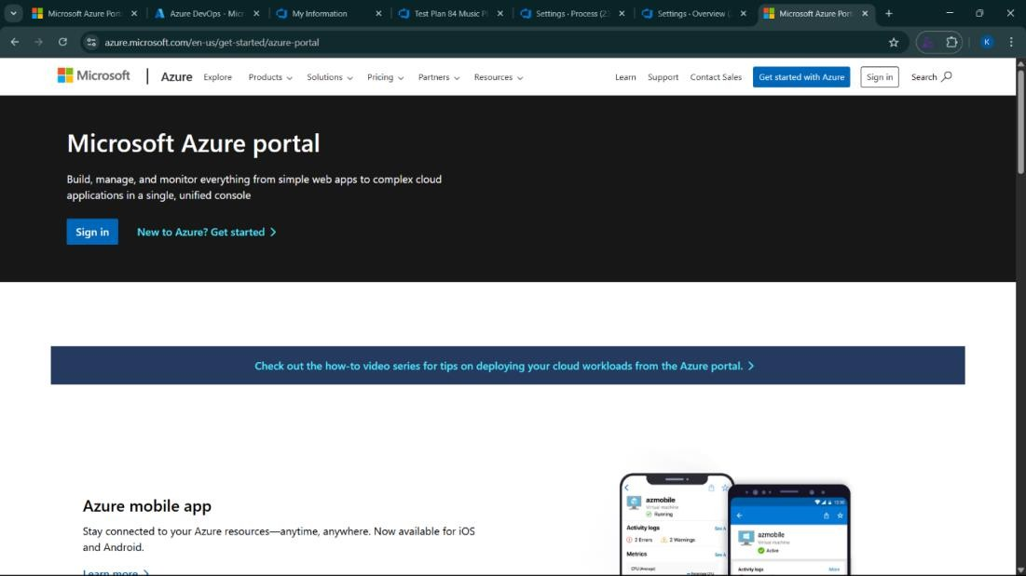

- Azure home page
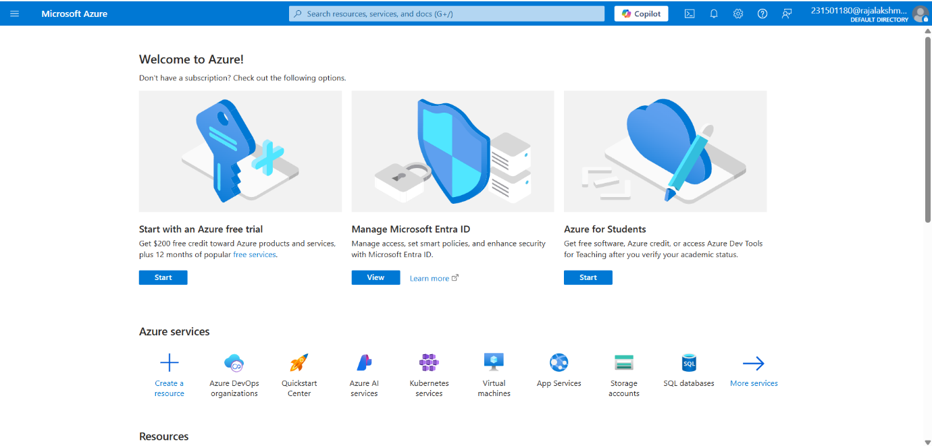
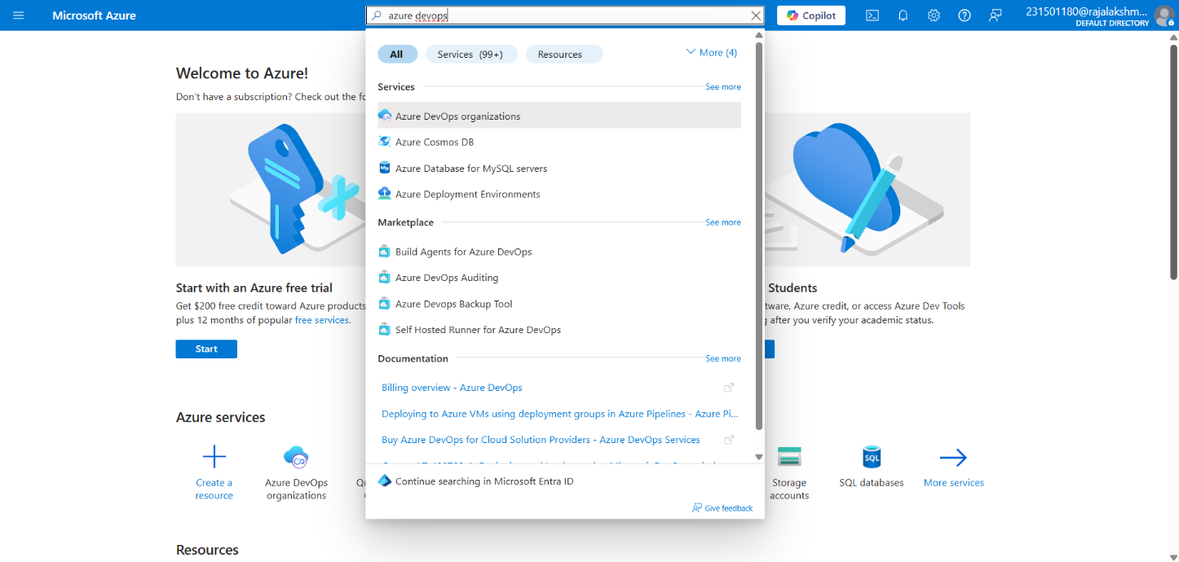
- Open DevOps environment in the Azure platform by typing Azure DevOps Organizations in the search bar.

- Click on the My Azure DevOps Organization link and create an organization and you should be taken to the Azure DevOps Organization Home page.

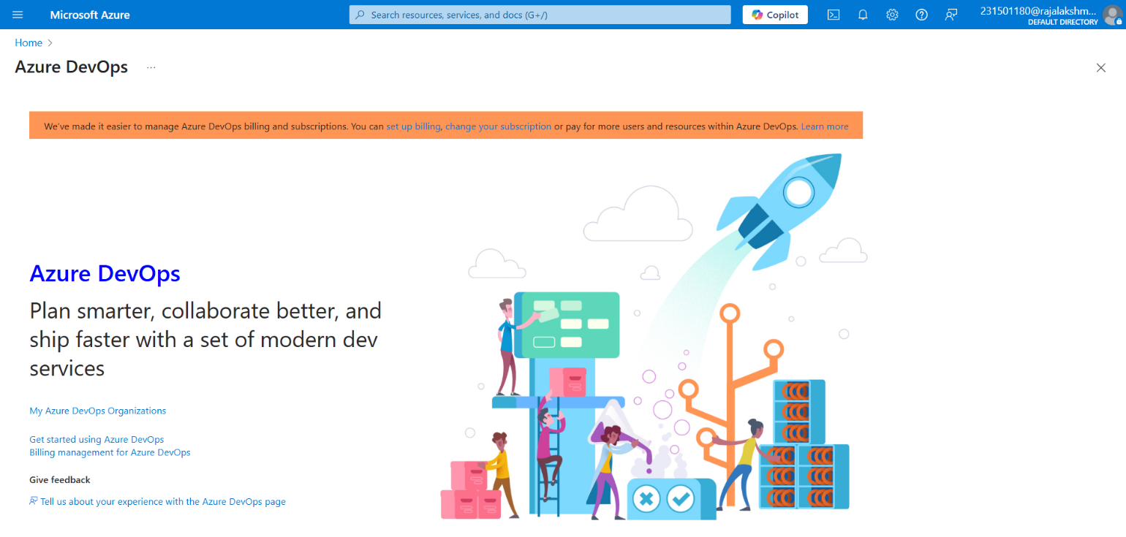

Result:
Successfully accessed the Azure DevOps environment and created a new organization through the Azure portal.

AZURE DEVOPS PROJECT SETUP AND USER STORY MANAGEMENT

EXP NO: 2

Aim:
Create Epic, Features, User Stories, Task
To set up an Azure DevOps project for efficient collaboration and agile work management.

- Create An Azure Account
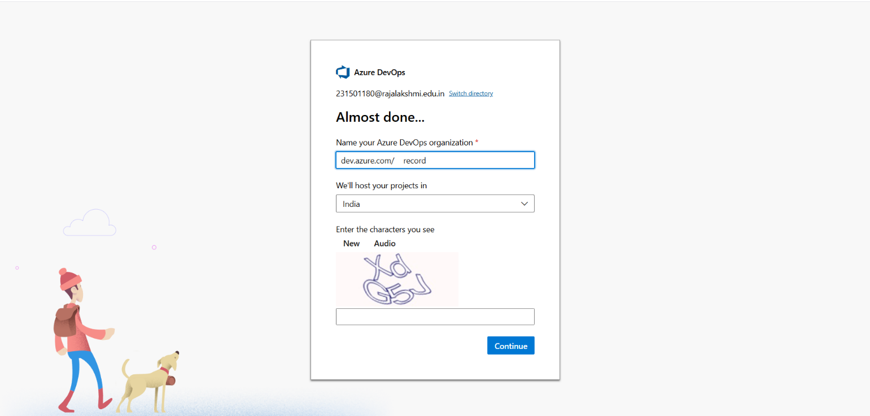

- Create the First Project in Your Organization
  - After the organization is set up, you’ll need to create your first project. This is where you'll begin to manage code, pipelines, work items, and more.
  - On the organization’s Home page, click on the New Project button.
  - Enter the project name, description, and visibility options:
Name: Choose a name for the project (e.g., LMS).
Description: Optionally, add a description to provide more context about the project. Visibility: Choose whether you want the project to be Private (accessible only to those invited) or Public (accessible to anyone).
  - Once you’ve filled out the details, click Create to set up your first project.

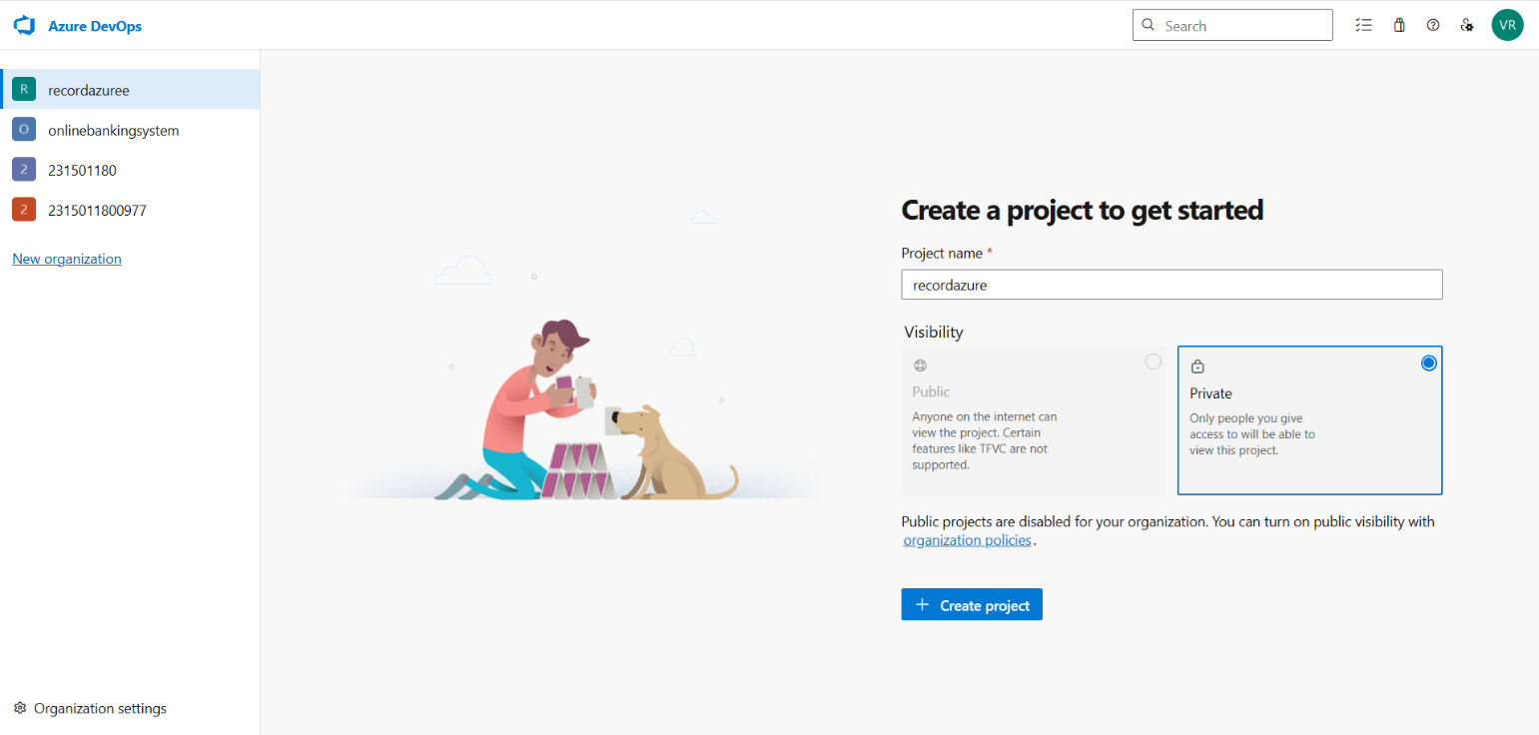

- Once logged in, ensure you are in the correct organization. If you're part of multiple organizations, you can switch between them from the top left corner (next to your user profile). Click on the Organization name, and you should be taken to the Azure DevOps Organization Home page.

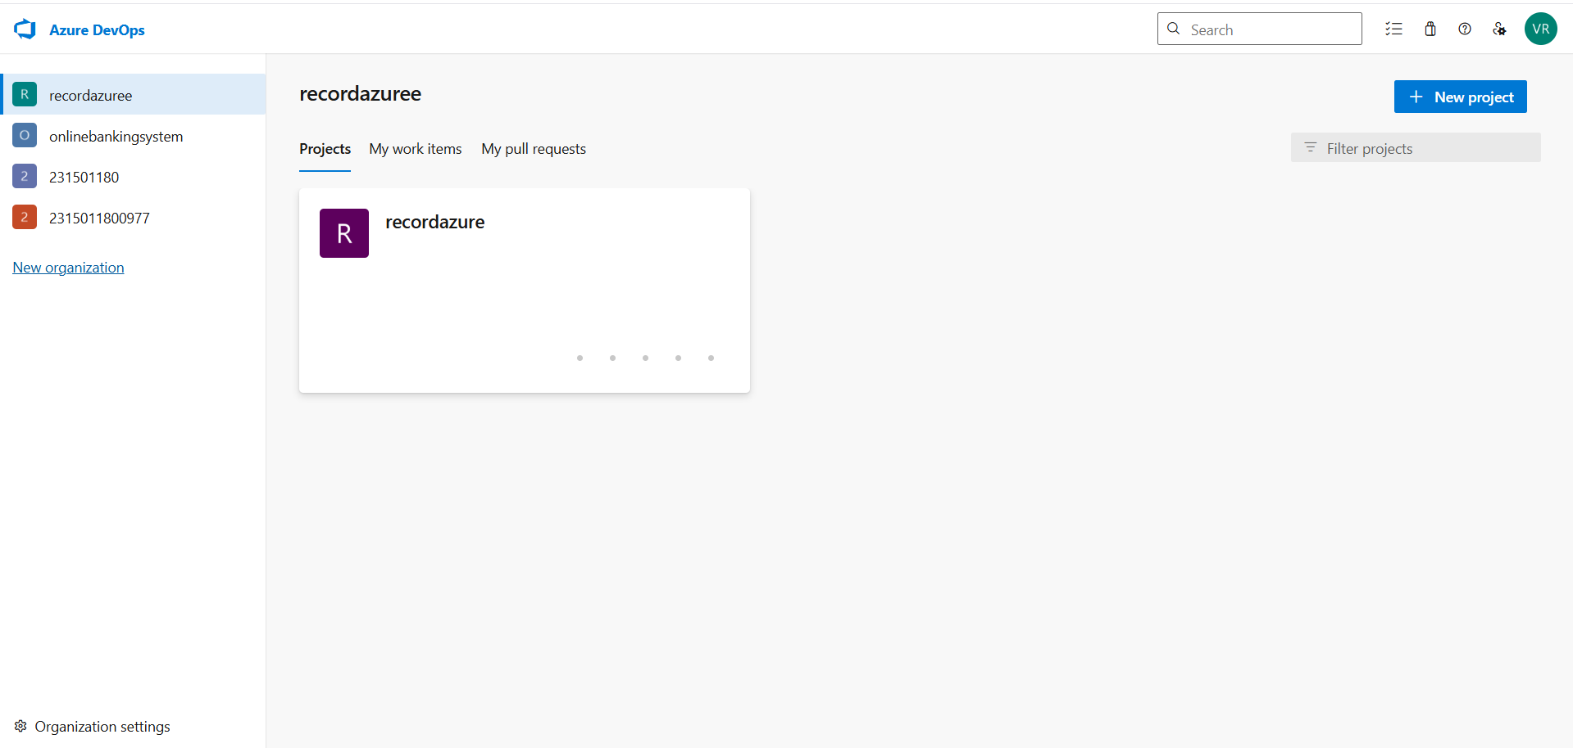

- Project dashboard
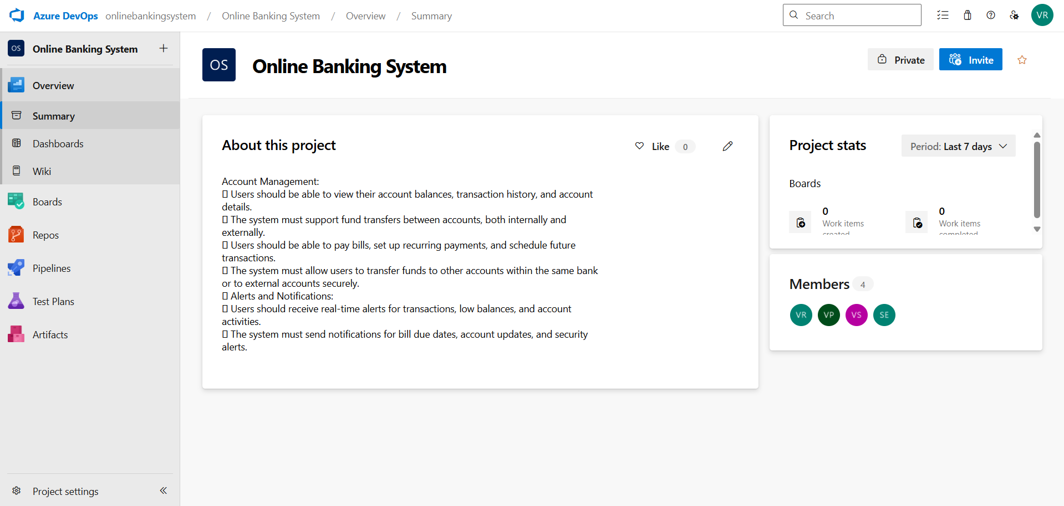

- To manage user stories:
  - From the left-hand navigation menu, click on Boards. This will take you to the main Boards
page, where you can manage work items, backlogs, and sprints.
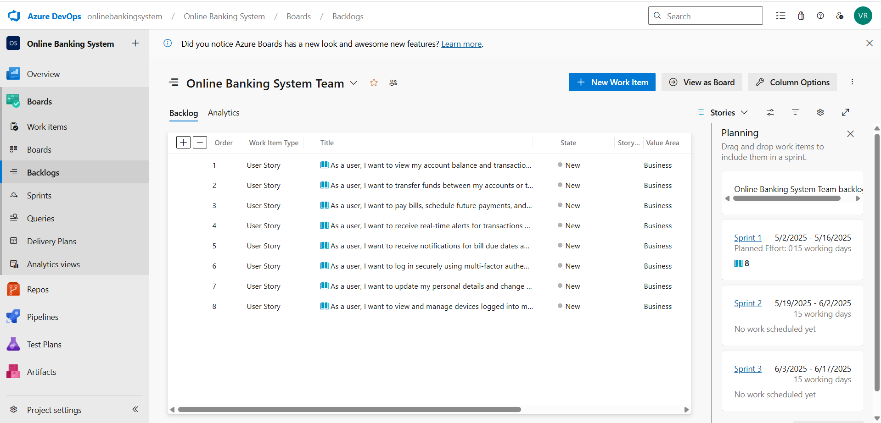
  - On the work items page, you'll see the option to Add a work item at the top. Alternatively, you can find a + button or Add New Work Item depending on the view you're in. From the Add a work item dropdown, select User Story. This will open a form to enter details for the new User Story.

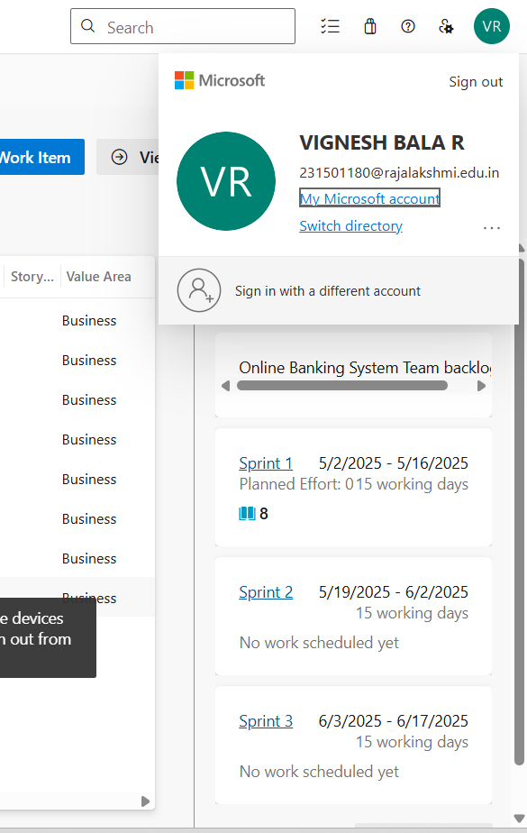

Result:

setup.

Successfully created an Azure DevOps project with user story management and agile workflow

SETTING UP EPICS, FEATURES, AND USER STORIES FOR PROJECT PLANNING

EXP NO: 3
Aim:
Create Epic, Features, User Stories, Task
To learn about how to create epics, user story, features, backlogs for your assigned project.

Create Epic, Features, User Stories, Task
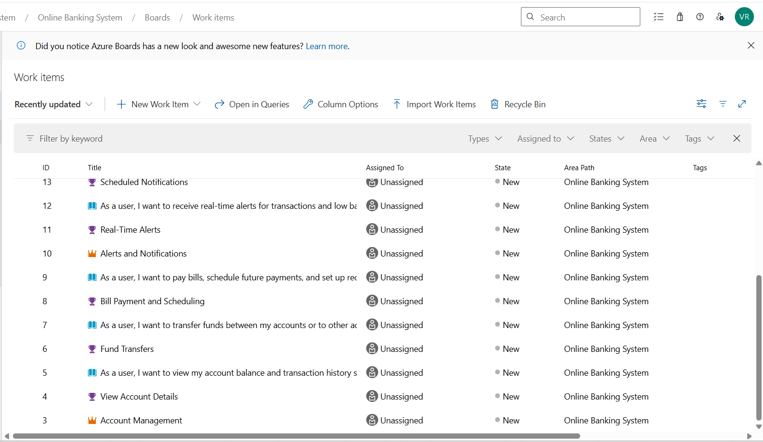

- Fill in Epics

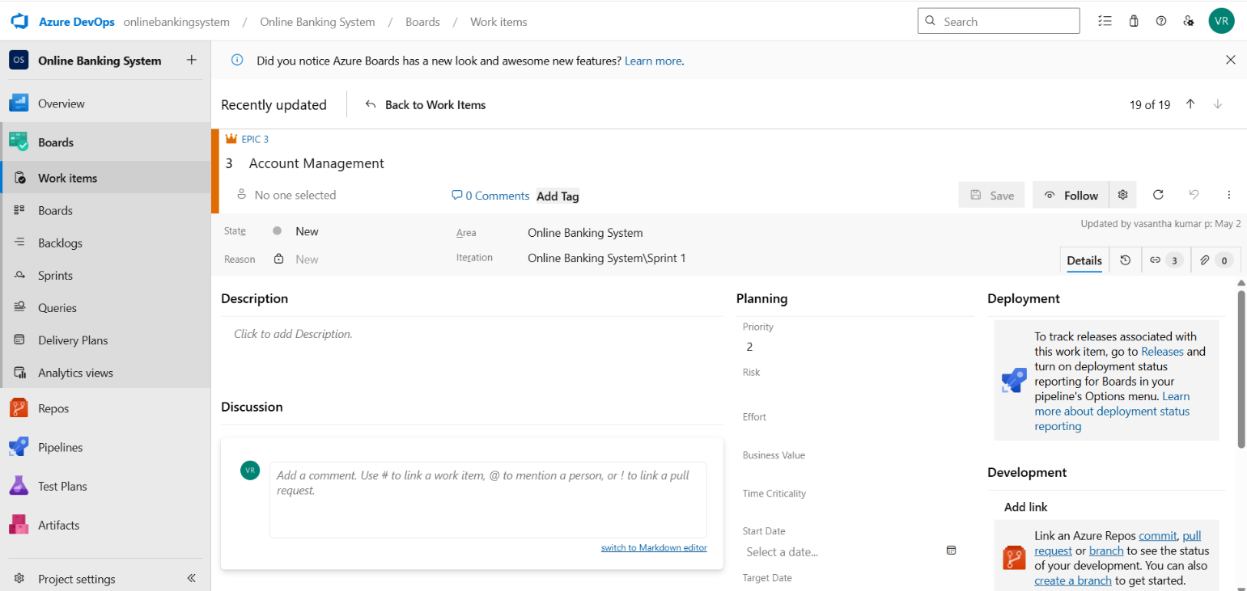
- Fill in Features

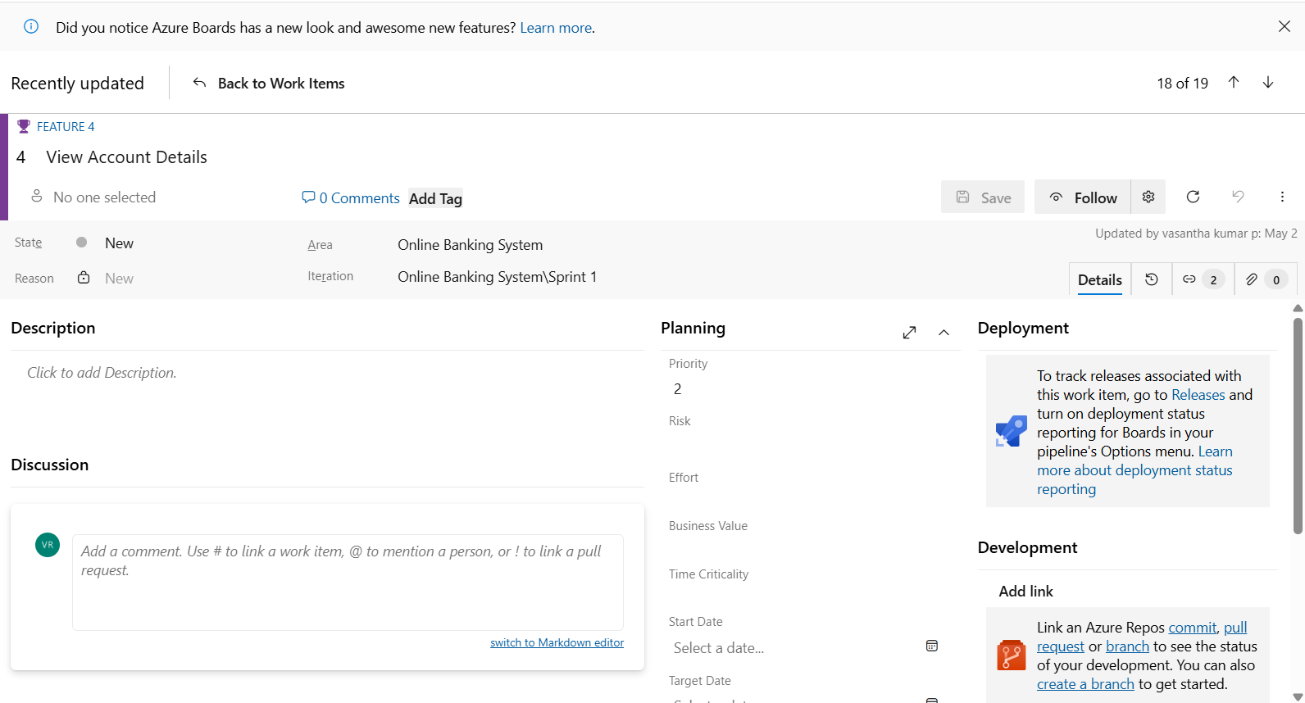
- Fill in User Story Details
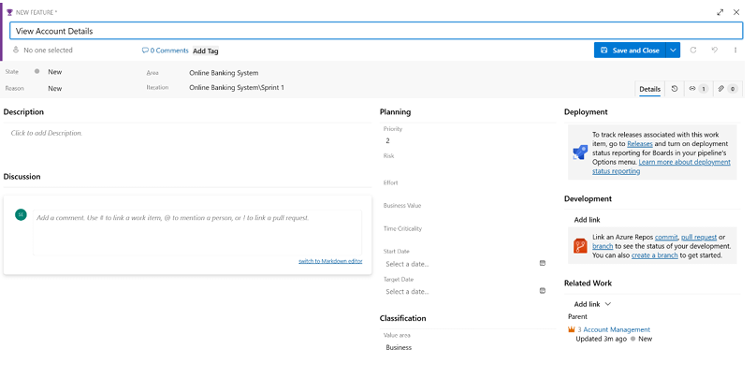

- Fill in User Story Details

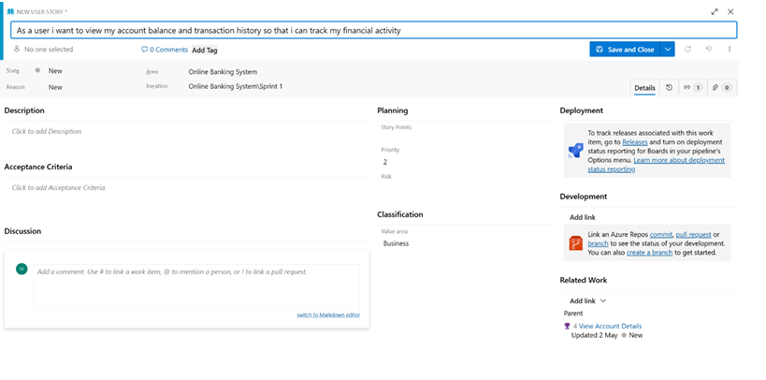

Result:
Thus, the creation of epics, features, user story and task has been created successfully.

SPRINT PLANNING

EXP NO: 4

Aim:
Create Epic, Features, User Stories, Task
To assign user story to specific sprint for the Online Banking System Project.

Sprint Planning Sprint 1
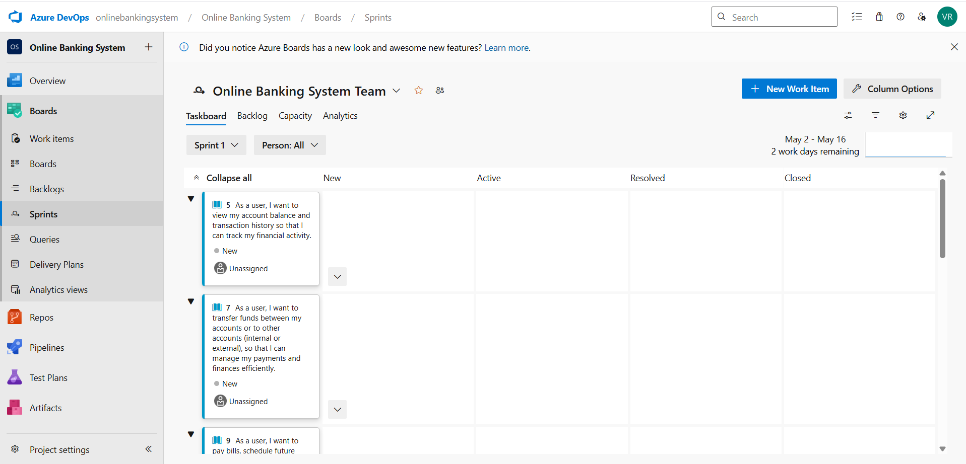

Sprint 2


Sprint 3


Sprint 4


Result:
The Sprints are created for the Online Banking System Project.

POKER ESTIMATION

EXP NO: 5

Aim:
Create Epic, Features, User Stories, Task
Create Poker Estimation for the user stories - Online Banking System Project.

Poker Estimation


Result:
The Estimation/Story Points is created for the project using Poker Estimation.

DESIGNING CLASS AND SEQUENCE DIAGRAMS FOR PROJECT ARCHITECTURE

EXP NO: 6

Aim:
Create Epic, Features, User Stories, Task
To Design a Class Diagram and Sequence Diagram for the given Project.

6 A. Class Diagram
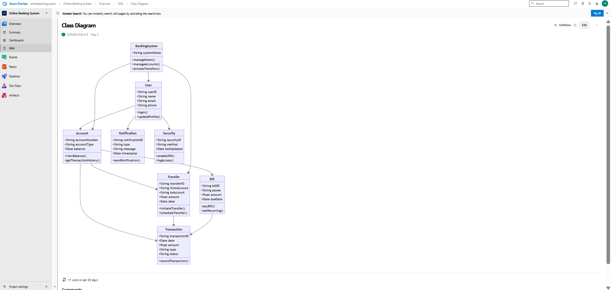

6 B. Sequence Diagram
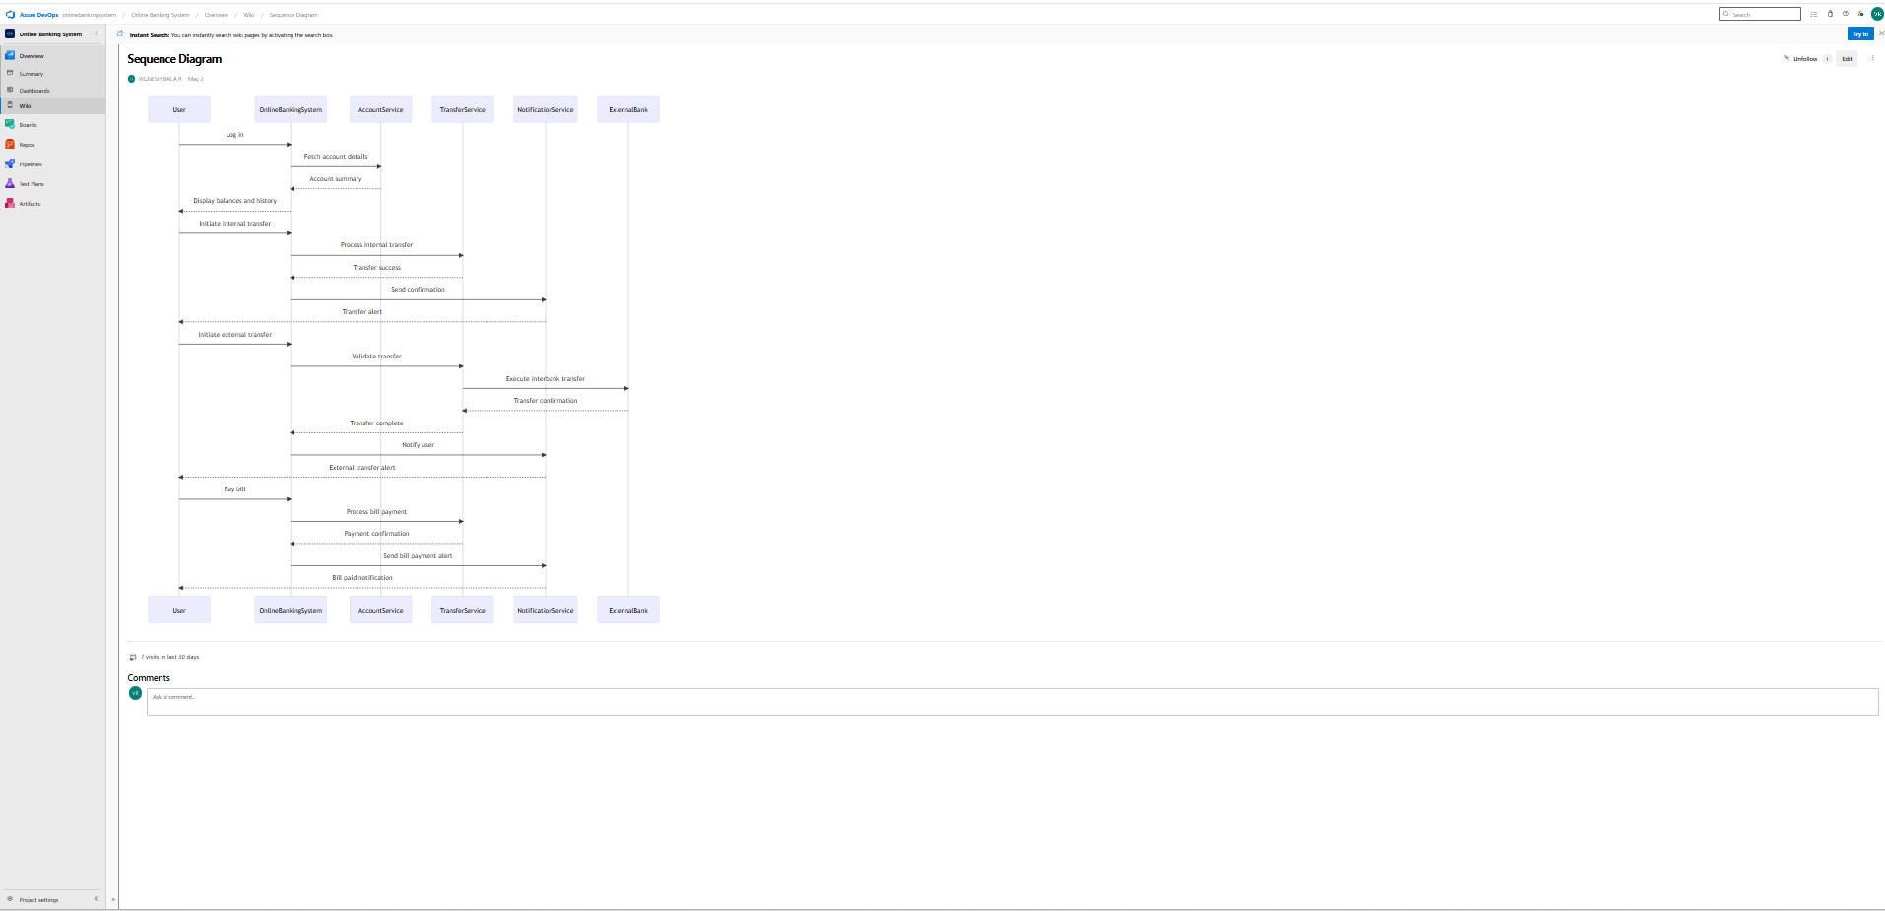

Result:
The Class Diagram and Sequence Diagram is designed Successfully for the Online Banking System.

DESIGNING ARCHITECTURAL AND ER DIAGRAMS FOR PROJECT STRUCTURE

EXP NO: 7

Aim:
Create Epic, Features, User Stories, Task
To Design an Architectural Diagram and ER Diagram for the given Project.

7A. Architectural Diagram
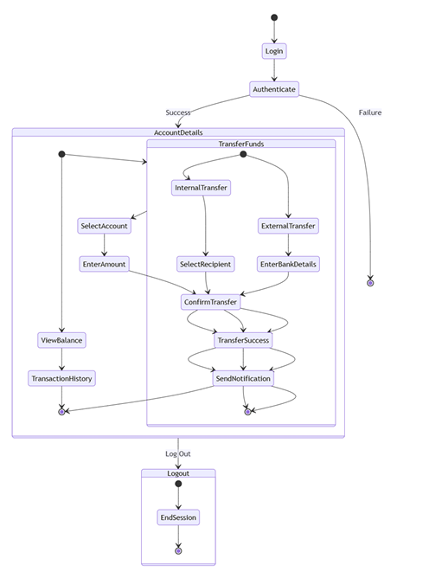

7B.ER Diagram
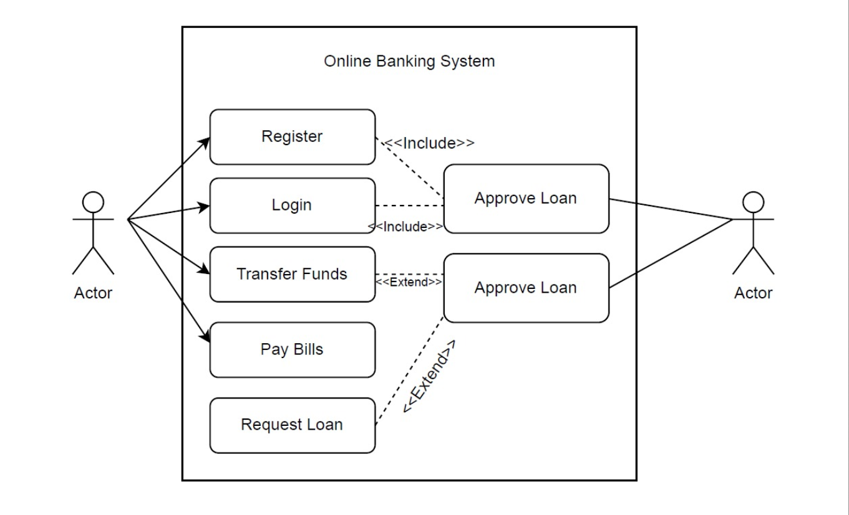

Result:

The Architecture Diagram and ER Diagram is designed Successfully for the Online Banking System

TESTING – TEST PLANS AND TEST CASES

EXP NO: 8
Aim:
Create Epic, Features, User Stories, Task
Test Plans and Test Case and write two test cases for at least five user stories showcasing the
happy path and error scenarios in azure DevOps platform.

Test Planning and Test Case Test Case Design Procedure
- Understand Core Features of the Application
  - User Signup & Login
  - Viewing and Managing Playlists
  - Fetching Real-time Metadata
  - Editing playlists (rename, reorder, record)
  - Creating smart audio playlists based on categories (mood, genre, artist, etc.)
- Define User Interactions
  - Each test case simulates a real user behaviour (e.g., logging in, renaming a playlist, adding a song).
- Design Happy Path Test Cases
  - Focused on validating that all features function as expected under normal conditions.
  - Example: User logs in successfully, adds item to playlist, or creates a category-based playlist.
- Design Error Path Test Cases
  - Simulate negative or unexpected scenarios to test robustness and error handling.
  - Example: Login fails with invalid credentials, save fails when offline, no recommendations found.
- Break Down Steps and Expected Results
  - Each test case contains step-by-step actions and a corresponding expected outcome.
  - Ensures clarity for both testers and automation scripts.
- Use Clear Naming and IDs
  - Test cases are named clearly (e.g., TC01 – Successful Login, TC10 – Save Playlist Fails).
  - Helps in quick identification and linking to user stories or features.
- Separate Test Suites
  - Grouped test cases based on functionality (e.g., Login, Playlist Editing, Recommendation System).

  - Improves organization and test execution flow in Azure DevOps.
- Prioritize and Review
  - Critical user actions are marked high-priority.
  - Reviewed for completeness and traceability against feature requirements.

- New test plan
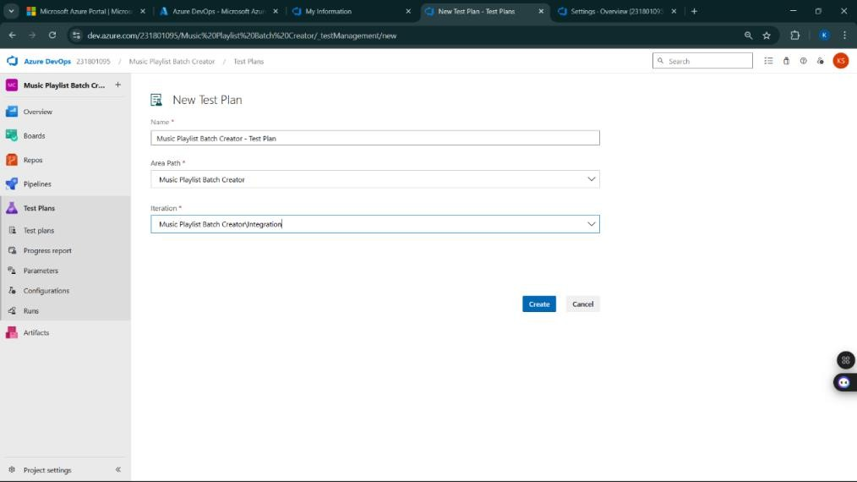

- Test suite
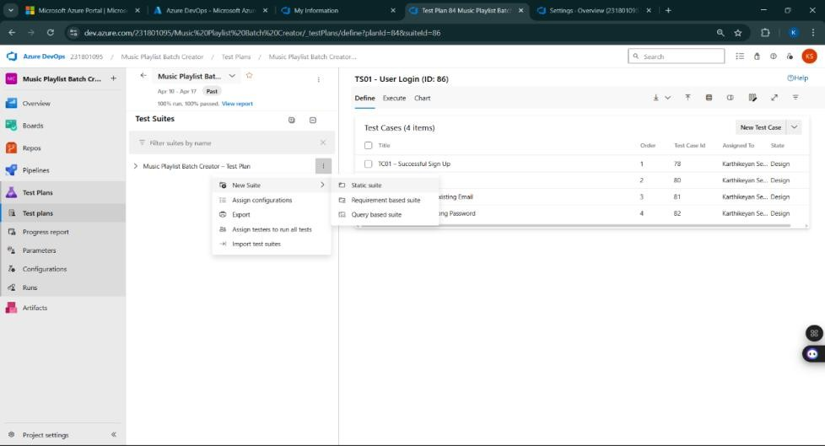

- Test case
Give two test cases for at least five user stories showcasing the happy path and error scenarios in azure DevOps platform.
Online Banking System – Test Plans
USER STORIES:
- US101: As a user, I want to register and log in securely to access my bank account.
- US102: As a user, I want to view my account balance and transaction history.
- US103: As a user, I want to transfer funds to another account securely.
- US104: As a user, I want to pay utility bills directly from my account.
- US105: As an admin, I want to manage user accounts and monitor transaction logs.
Test Suite: TS01 – User Registration & Login (ID: 301)
1. TC01 – Successful User Sign-Up
- Action:
  - Go to the Sign-Up page
  - Enter valid full name, email, and password
  - Click "Register"
- Expected Result:
  - User account is created and redirected to dashboard
- Type: Happy Path
2. TC02 – Login with Invalid Password
- Action:
  - Go to Login page
  - Enter registered email with incorrect password
  - Click "Login"
- Expected Result:
  - Error message: "Invalid email or password"
- Type: Error Path

Test Suite: TS02 – Account Overview (ID: 302)
3. TC03 – View Account Balance and Transactions
- Action:
  - Login → Navigate to "My Accounts"
  - Click on an account
- Expected Result:
  - Account balance and recent transactions are displayed
- Type: Happy Path
4. TC04 – View Transactions Without Login
- Action:
  - Directly access the account page without logging in
  - Try to open transactions
- Expected Result:
  - Error message: "Please log in to access account information"
- Type: Error Path

Test Suite: TS03 – Fund Transfer (ID: 303)
5. TC05 – Successful Fund Transfer
- Action:
  - Login → Navigate to "Transfer Funds"
  - Enter recipient account number and valid amount
  - Click "Transfer"
- Expected Result:
  - Success message: "Transfer completed successfully"
- Type: Happy Path
6. TC06 – Fund Transfer with Insufficient Balance
- Action:
  - Login → "Transfer Funds"
  - Enter recipient account and an amount exceeding available balance
  - Click "Transfer"
- Expected Result:
  - Error message: "Insufficient balance to complete transaction"
- Type: Error Path

Test Suite: TS04 – Bill Payments (ID: 304)
7. TC07 – Successful Utility Bill Payment
- Action:
  - Login → Go to "Pay Bills"
  - Select biller and enter payment amount
  - Click "Pay Now"
- Expected Result:
  - Confirmation: "Bill paid successfully"
- Type: Happy Path
8. TC08 – Pay Bill with Expired Card
- Action:
  - Login → "Pay Bills"
  - Use expired debit/credit card for payment
  - Click "Pay Now"
- Expected Result:
  - Error message: "Card expired – payment failed"
- Type: Error Path

Test Suite: TS05 – Admin Management (ID: 305)
9. TC09 – Admin Deactivates a User
- Action:
  - Login as Admin → Navigate to "User Management"
  - Select user → Click "Deactivate"
- Expected Result:
  - Confirmation: "User has been deactivated"
- Type: Happy Path
10. TC10 – Non-Admin Accessing Admin Features
- Action:
  - Login as regular user
  - Try to open "Admin Dashboard"
- Expected Result:
  - Error: "Access denied – admin privileges required"
- Type: Error Path

Test Cases
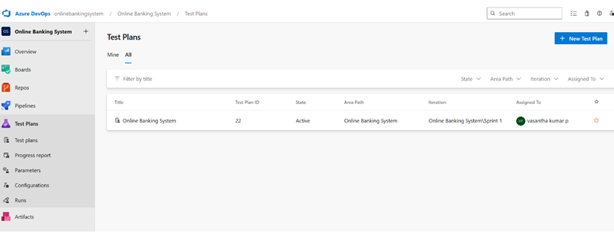

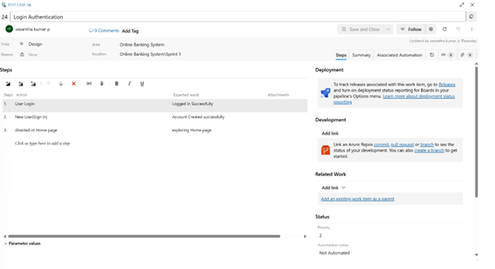
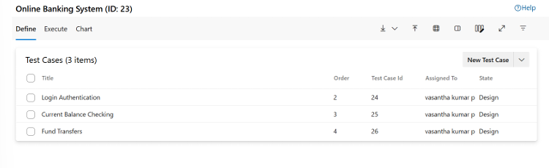
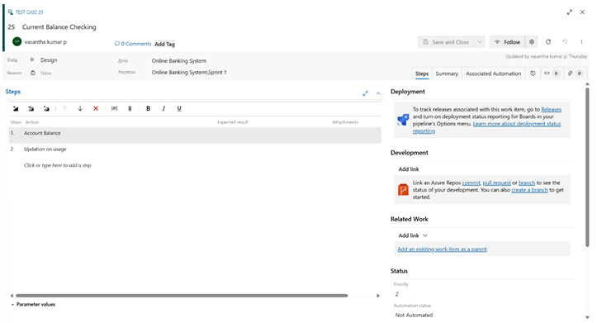
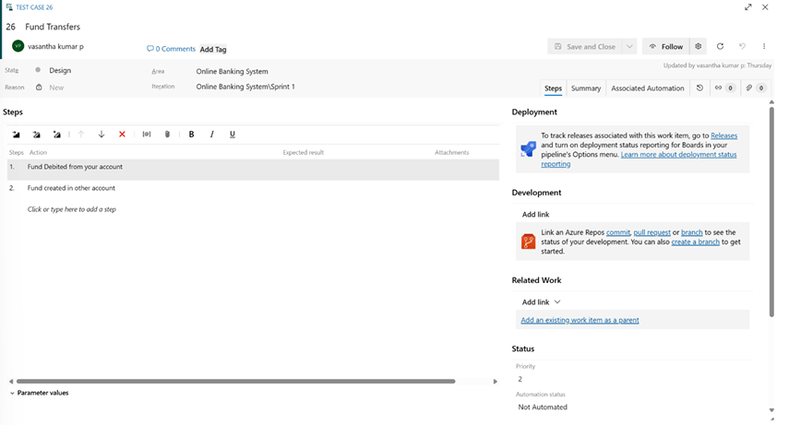

- Installation of test
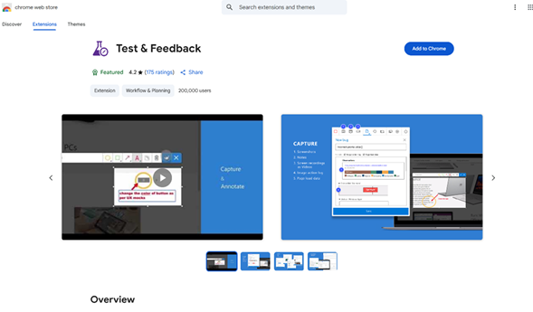

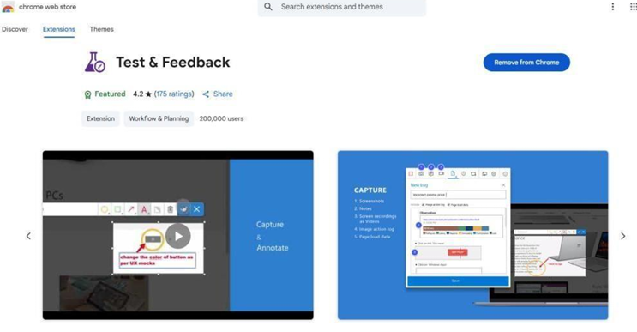

- Running the test cases
- 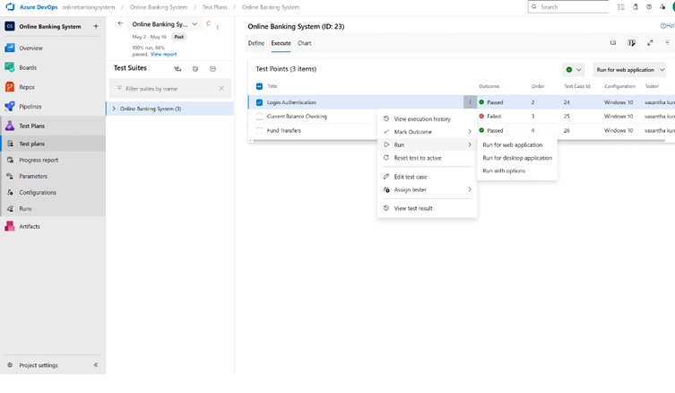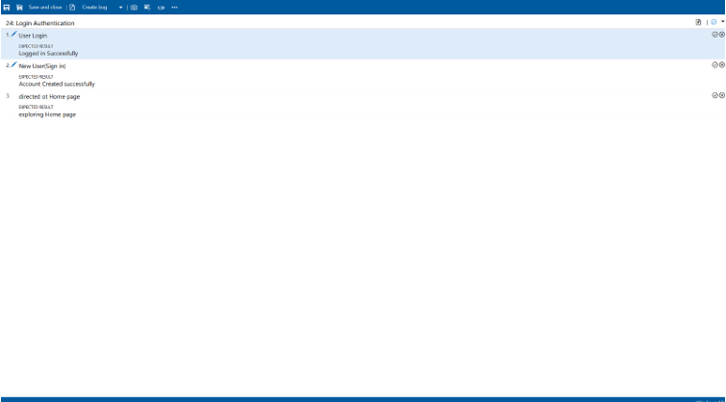

- Recording the test case
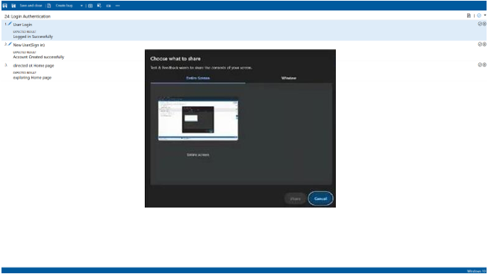

- Creating the bug
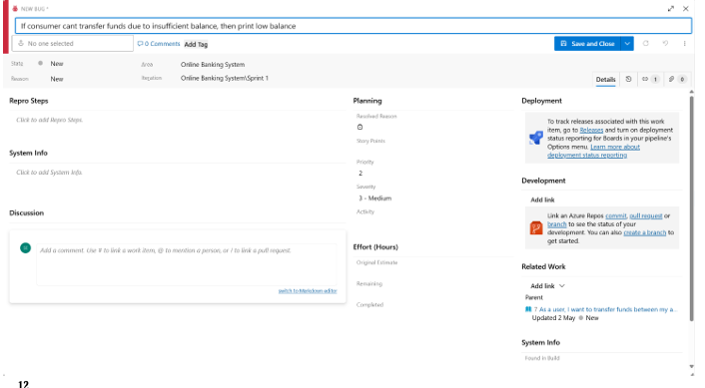

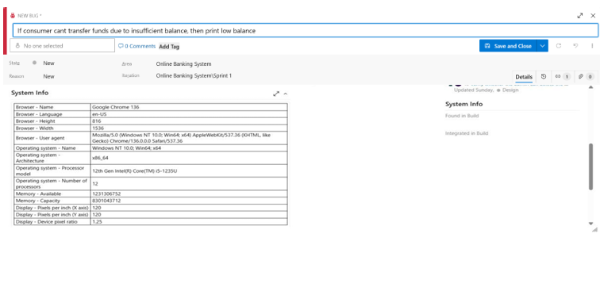

- Test case results
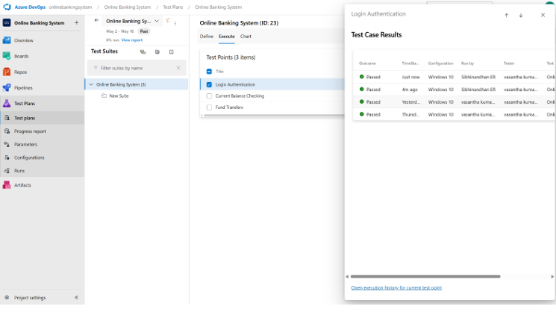

- Test report summary
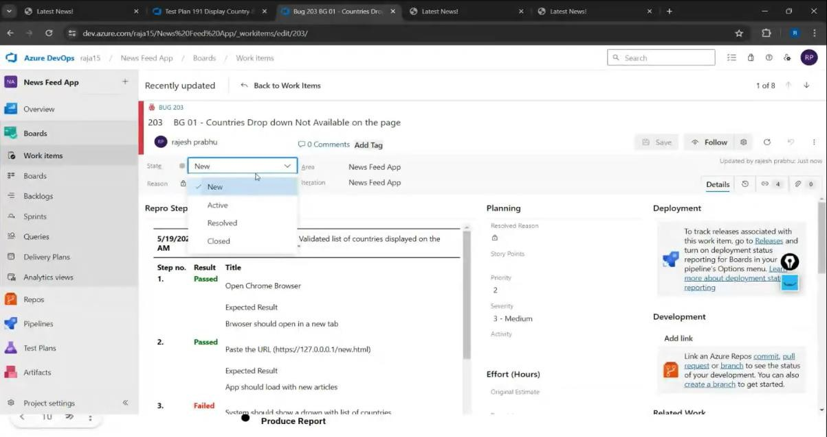

  - Assigning bug to the developer and changing state

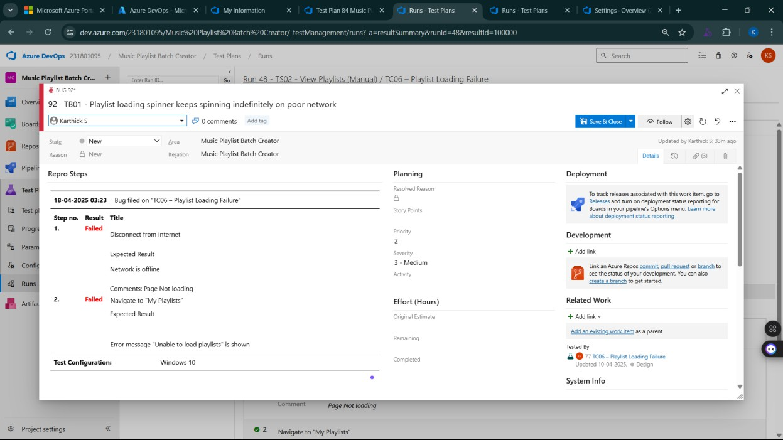

- Progress report
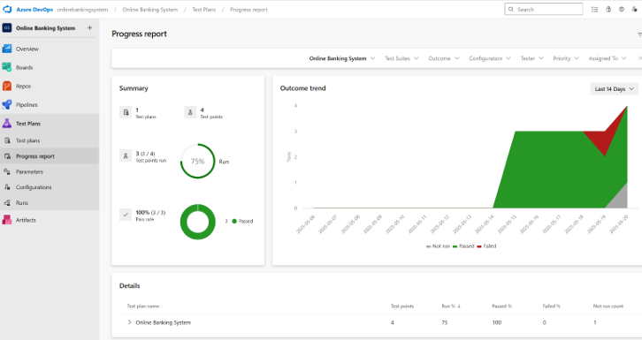

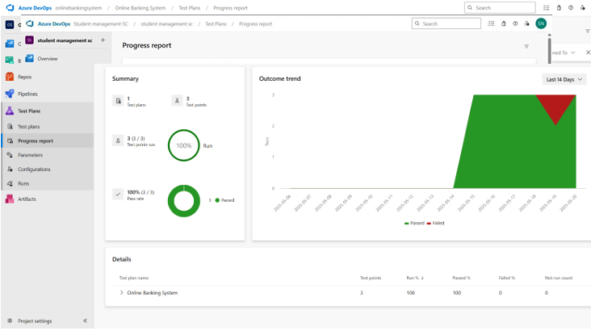

- Changing the test template
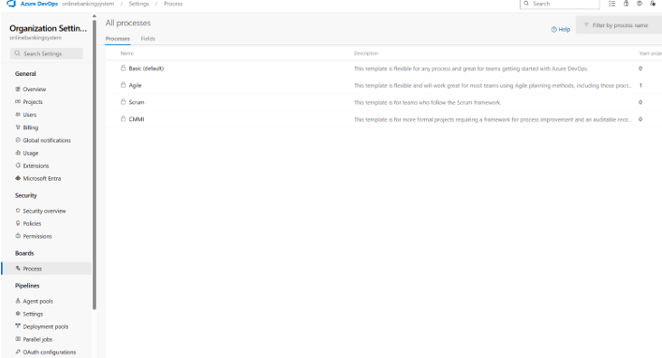

Result:
The test plans and test cases for the user stories is created in Azure DevOps with Happy Path and
Error Path

LOAD TESTING AND PERFORMANCE TESTING

EXP NO: 9

Aim:
Create Epic, Features, User Stories, Task
To create an Azure Load Testing resource and run a load test to evaluate the performance of a target endpoint.

Load Testing

Steps to Create an Azure Load Testing Resource:
Before you run your first test, you need to create the Azure Load Testing resource:
- Sign in to Azure Portal
Go to https://portal.azure.com and log in.
- Create the Resource
  - Go to Create a resource → Search for “Azure Load Testing”.
  - Select Azure Load Testing and click Create.
- Fill in the Configuration Details
  - Subscription: Choose your Azure subscription.
  - Resource Group: Create new or select an existing one.
  - Name: Provide a unique name (no special characters).
  - Location: Choose the region for hosting the resource.
- (Optional) Configure tags for categorization and billing.
- Click Review + Create, then Create.
- Once deployment is complete, click Go to resource.

Steps to Create and Run a Load Test:
Once your resource is ready:
- Go to your Azure Load Testing resource and click Add HTTP requests > Create.
- Basics Tab
  - Test Name: Provide a unique name.
  - Description: (Optional) Add test purpose.
  - Run After Creation: Keep checked.
- Load Settings
  - Test URL: Enter the target endpoint (e.g., https://yourapi.com/products).
- Click Review + Create → Create to start the test.

Load Testing
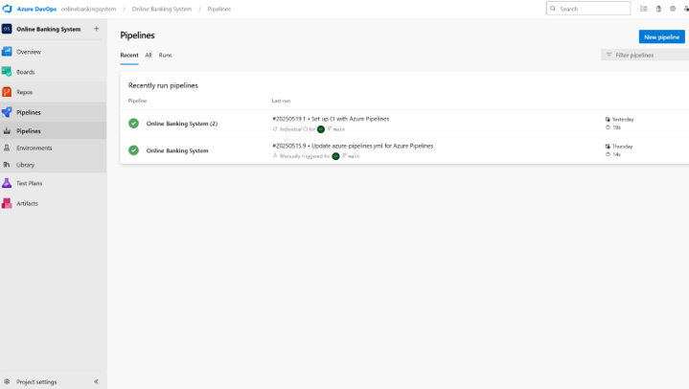

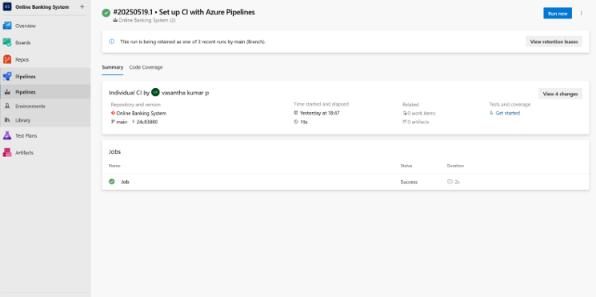

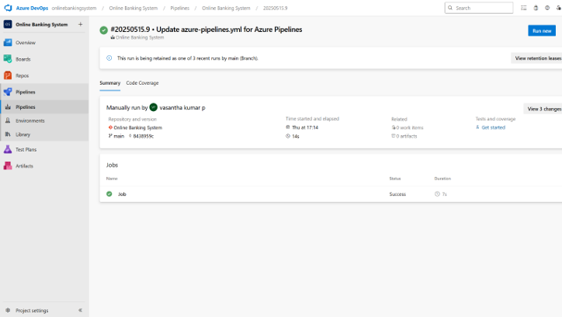

Result:
Successfully created the Azure Load Testing resource and executed a load test to assess the
performance of the specified endpoint.

GITHUB: PROJECT STRUCTURE & NAMING CONVENTIONS

EXP NO: 10

Aim:
Create Epic, Features, User Stories, Task
To provide a clear and organized view of the project's folder structure and file naming conventions, helping contributors and users easily understand, navigate, and extend the Online Banking System project.

GitHub Project Structure
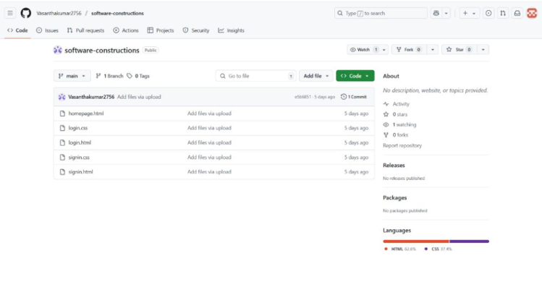

Result:
The GitHub repository clearly displays the organized project structure and consistent naming
conventions, making it easy for users and contributors to understand and navigate the codebase.

